HTML table

Objectives

The <form> tag

<form action = “”, method = “”>

* Action: The URL to send form data to
* Method – the type of HTTP request

</form>

* Get request
* Post request

The <input>tag

<input type = “text”>

<input type = “date”>

<input type = “color”>

<input type = “file”>

<input type = “checkbox”>

<input type = “password”>

Mdn search for input

HTML Forms

Getting User Input

Use the <form></form>

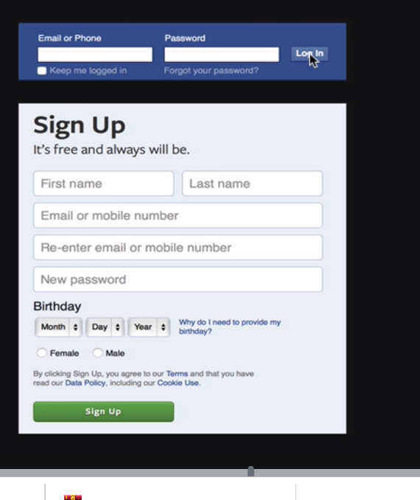

The input tag, create different type of input(MDN input (attributes, type))

Labels 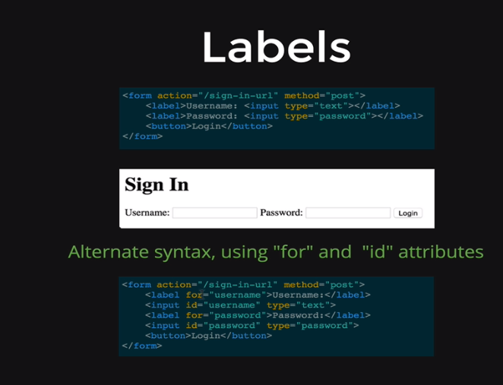

<form action="http://wikipedia.org" method="GET">

<label> Username:

<input type="text" placeholder="username">

</label>

<label> Password:

<input type="password" placeholder="password">

</label>

<input type="submit"> <!-- identical -->

</form>

Simple validations

Required tag

Select tag( create nice drop down menu